***Background and Business problem –***

ABC company has a drug, "Liva", which is the current best medicine available in Multiple Sclerosis *(a chronic, typically progressive disease involving damage to the sheaths of nerve cells in the brain and spinal cord, whose symptoms may include numbness, impairment of speech and of muscular coordination, blurred vision, and severe fatigue)* market. ABC currently has a competition from other pharma companies that manufacture drugs in the same market. It came to know that XYZ company is launching its new oral drug "Ziva" which got its FDA approval in January 2021 which has a greater efficacy compared to Liva. ABC has reached out to us for creating a monthly trend for oral drugs to identify the areas of growth in the MS market. If the new drug launches and excels in the market, the sales of the ABC company will decline as the new drug, “Ziva”, will be given to patients by physicians. Since the launch of the ABC drug, no monthly analysis/trends related to the market are created as this is the best drug in the market till December 2020. There are other drugs present in the market but have not been a competition as the drug is in profits since the launch. However, to check for the drug’s position in the market, a semesterly analysis using claims data is performed by the ABC company itself.

***Business Value –***

Given this new drug launch, ABC wants to understand the market share of the drug in comparison to all the drugs available. Based on the monthly market share and physicians that write the ABC company’s drug, “Liva”, from the reports, they will target the certain pool of physicians who comply and stay loyal to the brand and continue prescribing the drug. The monthly shares will be used in the annual conference held by the company to report the performance of the drug which will help in making important decisions based on the results reported.

ABC purchased secondary claims data from DEF vendor that has data from January 2019 - December 2020. The company wants the Team 12 to load the data, set-up an end-to-end process, analyze the data and create the final reports. Data purchased from DEF vendor has 9 tables that has diagnosis, pharmacy and procedure related claims for all market areas which will be used for our analysis.

Below is the summary of the project for Team 12 –

***Output of the project –***

1. Monthly claim counts by drugs.
2. Monthly patient counts by physician specialty.
3. Yearly patient counts by book of business.
4. Yearly patient counts by demography.
5. Physician target list

***Business rules –***

1. Only approved and reversed claims are considered in the analysis. Market name filter is applied as "Multiple Sclerosis". (Claim Status =1 and 2 in RX Claims table). For a patient to be a confident Multiple Sclerosis patient, he should have at least one diagnosis claim or one procedure claim on the rx claims.
2. Only active patients are considered and patients with age greater than 100 are excluded.
3. Patient to physician mapping is done, i.e., one patient can have only one primary physician.
4. Claims with only market name as "MS" are considered for this analysis.

***Detailed description of business rules –***

The data is captured using switches by the data vendors. Each patient is given a distinct patient ID to be identified across the data. A patient can have multiple claims for same disease on same day as well. Patients can also have treatments from multiple physicians but only one physician remains as a primary physician in the data period. Patient having a Rx claim may or may not have a diagnosis or a procedure on the same claim. Patient can have multiple plans, however, only one plan is mapped to a patient in a year. For data captured for the patients, it will have the entire health history of the patient - a filter on the market name is required.

***Data Dictionary –***

|  |  |  |  |
| --- | --- | --- | --- |
| **Entity Name** | **Column Name** | **Description** | **Data Type** |
| **DrugClaims_RX**  **All the prescription claims given by the physician to the patient will be stored in this entity. This entity contains information related to drug and its market, insurance plan ID the patient is using to get the drug from the physician.** | claim_id | Interaction ID of the patient | char(15) |
| ptnt_id | Patient identifier | char(11) |
| phys_id | Physician identifier | char(9) |
| drug_code | Drug name identifier | char(6) |
| dos | Days of supply of the drug | int |
| clm_sts | Claim status; whether the claim is   1 - Approved  2 - Reversed  0 - Rejected | int |
| clm_date | Date of the prescription | date |
| pln_id | Insurance plan ID of the patient | char(18) |
| mkt_nm | Disease market name | varchar(20) |
|  |  |  |  |
| **DiagnosisClaims_DX**  **This entity has the information related to diagnosis a patient has received** | claim_id | Interaction ID of the patient | char(15) |
| ptnt_id | Patient identifier | char(11) |
| diag_date | Date of diagnosis taken | date |
| diag_code | Diagnosis code | char(8) |
| mkt_nm | Disease market name | varchar(20) |
|  |  |  |  |
| **ProcedureClaims_PX**  **This entity has the information related to any kind of procedures like Xray, injections, surgies received by the patient** | claim_id | Interaction ID of the patient | char(15) |
| ptnt_id | Patient identifier | char(11) |
| proc_code | Procedure code identifier | char(8) |
| proc_date | Procedure date | date |
| mkt_nm | Disease market name | varchar(15) |
|  |  |  |  |
| **Patient_Dimension**  **This entity provided information related to patient and whether he/she is active or not. If he is active in the last 365 days, his status will be 1, else 0** | ptnt_id | Patient identifier | char(11) |
| ptnt_birth_yr | Patient birth year | int |
| ptnt_gender | Patient gender -   M - male  F - female | char(1) |
| ptnt_status | Patient active status   1 - patient is active in last 365 days  0 - patient is inactive in last 365 days | int |
|  |  |  |  |
| **Physician_Dimension**  **All the physician information like name, address, primary speciality, ID provided by the government will be stored in this entity** | phys_id | Physician identifier | char(9) |
| phys_first_nm | Physician first name | varchar(20) |
| phys_last_nm | Physician last name | varchar(20) |
| phys_middle_nm | Physician middle name | varchar(20) |
| phys_address | Physician address | varchar(50) |
| phys_city | Physician city | varchar(20) |
| phys_st | Physician state | varchar(15) |
| phys_zip | Physician zip code | char(6) |
| phys_spec_cd | Physician primary specialty | varchar(20) |
| phys_spec_desc | Physician specialty description | varchar(40) |
| phys_npi | National provider identifier | char(8) |
| ptnt_id | Patient identifier | char(11) |
|  |  |  |  |
| **Drug_Dimension**  **Drug, drug code given by the government, its decription, its dosage strength like 100mg,200mg will be stored under this entity** | drug_code | Drug name identifier | char(6) |
| ndc | National drug code | char(6) |
| drg_nm | Drug description | varchar(20) |
| drg_stgth | Drug strength | varchar(20) |
|  |  |  |  |
| **Procedure_Dimension**  **The procedure like Xray, injection, surgery and its related description will be stored in this entity** | proc_code | Procedure code identifier | char(8) |
| proc_desc | Procedure description | varchar(30) |
|  |  |  |  |
| **Diagnosis_Dimension**  **Diagnosis code and description are stored in this entity** | diag_code | Diagnosis code | char(10) |
| diag_desc | Diagnosis description | varchar(50) |
|  |  |  |  |
| **Plan_Dimension**  **This entity contains all the insurance plans that are available, plan providing companies, book of business details like whether the plan is provided by government or private, and the sub plan payer like Medicare primary, Medicare secondary etc.** | pln_id | Insurance plan ID | char(14) |
| pln_desc | Plan description | varchar(50) |
| parent_payer | Payer name | varchar(20) |
| sub_pln | Sub plan payer | varchar(20) |
| bob | Book of business, eg., Commercial, Medicare, Medicaid, etc., | varchar(20) |

***EERD –***

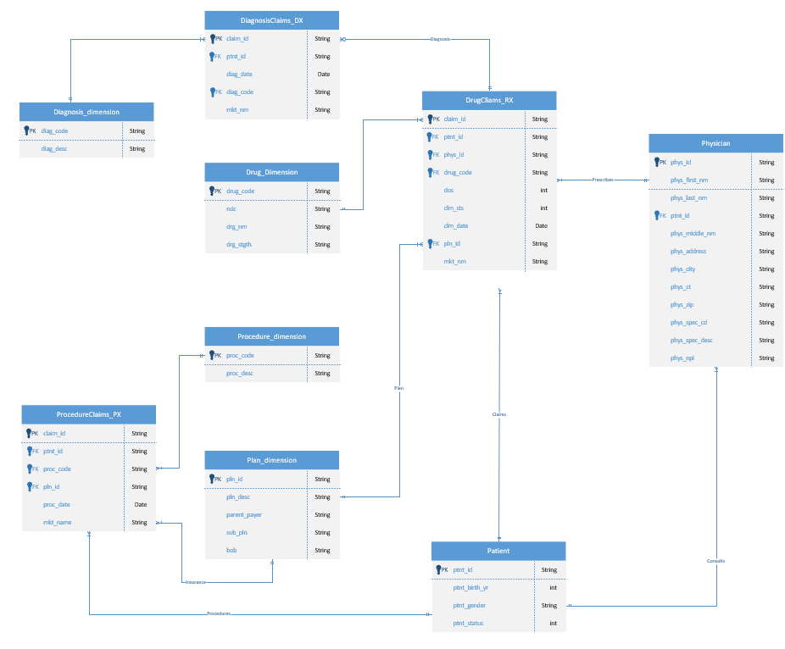

***Swinlane diagram -***

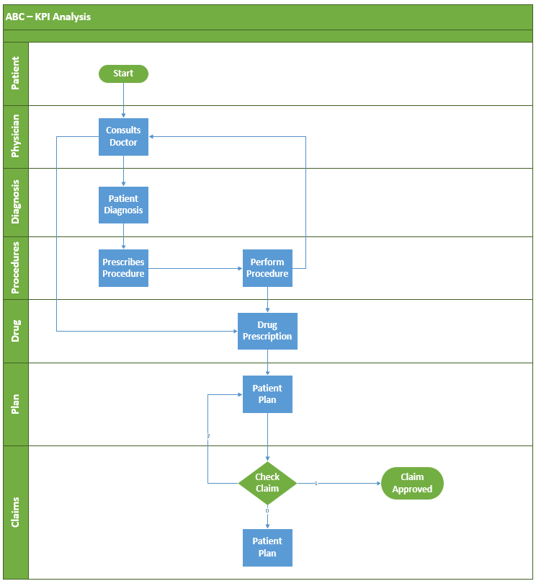

***Reports –***

**Report 1 -** Monthly claim counts by drugs for all active patients with a diagnosis and procedure for the patient for all approved or reversed claims.

This report will give the number of claims that are generated by the patients for various drugs in the MS market. All the patients in this report are active i.e they have consulted the physician within the last 365 days. And all these patients have been diagnosed and procedures were performed on them. All the claims in this report are either approved or reversed. This report will help us understand how our drug (Liva) is performing in the Multiple Sclerosis market.

Code -

*/

*select drg_nm, months1, count(*) as claims from*

*(*

*select f.*, h.drg_nm, to_char(clm_date,'rrrr-mm') as months1 from*

*(*

*select distinct d.* from*

*(*

*select a.* from drugclaims_rx a*

*inner join patient b*

*on a.ptnt_id=b.ptnt_id*

*where ptnt_status =1*

*) d*

*inner join diagnosisclaims_dx c*

*on d.ptnt_id=c.ptnt_id*

*inner join procedureclaims_px e*

*on d.ptnt_id=e.ptnt_id*

*) f*

*left join drug h*

*on f.drug_code=h.drug_code*

*) i*

*where clm_sts in (1,2)*

*group by drg_nm, months1*

*order by months1 asc;*

*/

Output -

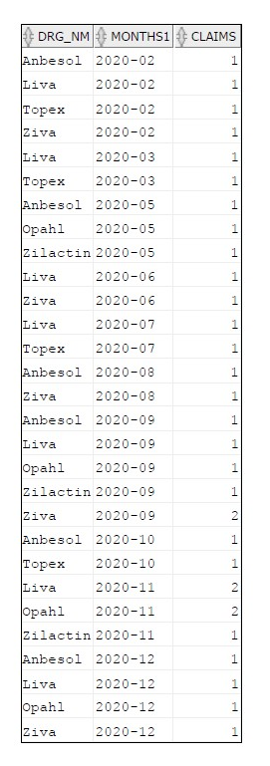

**Report 2 -** Monthly patient counts by physician specialty for all active patients with a diagnosis and procedure for the patient for all approved or reversed claims.

This report will generate the number of patients visiting a particular physician of a certain speciality. The patients in this report are active and the claims are either reversed or approved. This is useful to identify the specialties that are prescribing drugs for MS disease.

Code -

*/

*select months,phys_spec_cd, count(distinct ptnt_id) as patients from*

*(*

*select f.*, g.phys_spec_cd,to_char(clm_date,'rrrr-mm') as months from*

*(*

*select distinct d.* from*

*(*

*select a.* from drugclaims_rx a*

*inner join patient b*

*on a.ptnt_id=b.ptnt_id*

*where ptnt_status =1*

*) d*

*inner join diagnosisclaims_dx c*

*on d.ptnt_id=c.ptnt_id*

*inner join procedureclaims_px e*

*on d.ptnt_id=e.ptnt_id*

*) f*

*left join physician g*

*on f.phys_id=g.phys_id*

*) h*

*where clm_sts in (1,2)*

*group by months,phys_spec_cd;*

Output -

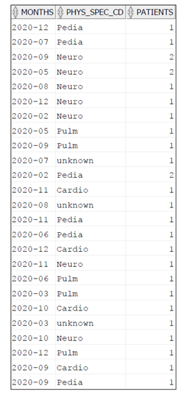

**Report 3 -** Yearly patient counts by BoB for all active patients with a diagnosis and procedure for the patient for all approved or reversed claims.

Book of business (BoB) is used to identify the plans that each patient takes in a year. Generally, a patient remains on one plan for an entire year. This report is used to see if there are any restrictions for prescribing drugs. For example, if there are 10 patients under “Commercial” BoB and just 3 patients under “Private”, this shows that there Commercial payers have fewer restrictions on MS drugs compared to “Private” payers.

Code -

*/

*select years, bob, count(distinct ptnt_id) as patients from*

*(*

*select f.*,g.bob, extract(year from clm_date) as years from*

*(*

*select distinct d.* from*

*(*

*select a.* from drugclaims_rx a*

*inner join patient b*

*on a.ptnt_id=b.ptnt_id*

*where ptnt_status =1*

*) d*

*inner join diagnosisclaims_dx c*

*on d.ptnt_id=c.ptnt_id*

*inner join procedureclaims_px e*

*on d.ptnt_id=e.ptnt_id*

*) f*

*left join plan1 g*

*on f.pln_id =g.pln_id*

*)*

*where clm_sts in (1,2)*

*group by years,bob;*

Output -

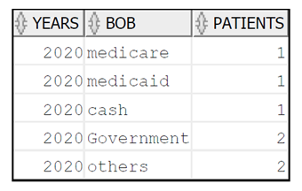

**Report 4 -** Quarterly patient counts by demography for all active patients with a diagnosis and procedure for the patient for all approved or reversed claims

This report generates the quarterly results of the patients in a particular demographic region who are diagnosed and procedures were performed. All the claims are either approved or reversed. This will help ABC company to assess the markets in different geographic regions and introduce drug Liva.

Code -

*/

*select year_quarter, phys_city, count(distinct ptnt_id) as patients from*

*(*

*select f.*,g.phys_city, extract(year from clm_date)||'Q'||ceil(extract(month from clm_date)/3) as year_quarter from*

*(*

*select distinct d.* from*

*(*

*select a.* from drugclaims_rx a*

*inner join patient b*

*on a.ptnt_id=b.ptnt_id*

*where ptnt_status =1*

*) d*

*inner join diagnosisclaims_dx c*

*on d.ptnt_id=c.ptnt_id*

*inner join procedureclaims_px e*

*on d.ptnt_id=e.ptnt_id*

*) f*

*left join physician g*

*on f.phys_id=g.phys_id*

*)*

*where clm_sts in (1,2)*

*group by year_quarter,phys_city*

*order by year_quarter;*

Output -

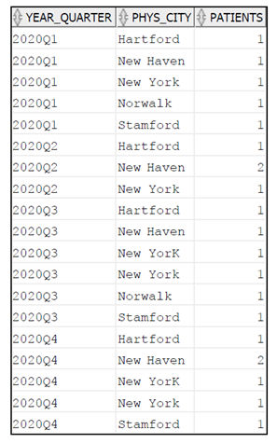

**Report 5 -** Create a physician target list that has all the demographic information of the physician, count of drug claims, patients for all drugs and Liva for all approved or reversed claims and active patients only.

This report can give a snapshot of how many physicians are prescribing a particular drug in a geographic region for all the active patients, for both approved and reversed claims. It can help us assess how many physicians are prescribing the drug of ABC company, Liva, in a specific demographic. This report is used by the business and marketing teams to identify the potential physicians that can be targeted.

Code -

*/\**

*select e.*, MS_claims,liva_claims, MS_patients,liva_patients, MS_2020Q1_patients, MS_2020Q2_patients, MS_2020Q3_patients, MS_2020Q4_patients from*

*(*

*select phys_id, count(*) as MS_claims,*

*count(case when drg_nm='Liva' then claim_id end) as liva_claims,*

*count(distinct ptnt_id) as MS_patients,*

*count(distinct case when drg_nm='Liva' then ptnt_id end) as liva_patients,*

*count(distinct case when year_quarter='2020Q1' then ptnt_id end) as MS_2020Q1_patients,*

*count(distinct case when year_quarter='2020Q2' then ptnt_id end) as MS_2020Q2_patients,*

*count(distinct case when year_quarter='2020Q3' then ptnt_id end) as MS_2020Q3_patients,*

*count(distinct case when year_quarter='2020Q4' then ptnt_id end) as MS_2020Q4_patients from*

*(*

*select a.*,c.drg_nm, extract(year from clm_date)||'Q'||ceil(extract(month from clm_date)/3) as year_quarter from drugclaims_rx a*

*inner join patient b*

*on a.ptnt_id=b.ptnt_id*

*left join drug c*

*on a.drug_code=c.drug_code*

*where ptnt_status=1 and clm_sts in (1,2)*

*) c*

*group by phys_id*

*) d*

*left join physician e*

*on d.phys_id=e.phys_id*

*order by MS_patients desc;*

Output -

